World Religions Organizer: Monotheistic Faiths
Religion | Judaism | Christianity | Islam
Founder
Basic Beliefs
Sacred Text
(Holy Book)
Name of deities
(gods or goddesses)
Important rituals and/or holidays
Where Religion Originated  How many followers are there Worldwide? | 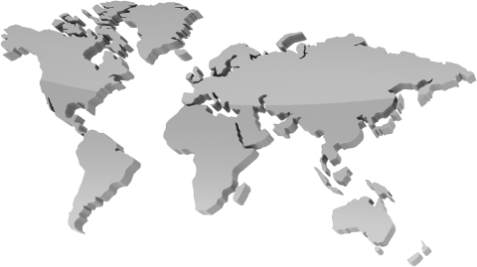

World Religions Organizer
Religion | Buddhism | Hinduism | Confucianism | Daoism
Founder
Basic Beliefs
Sacred Text
(Holy Book)
Name of deities
(gods or goddesses)
Important rituals and/or holidays
Where Religion Originated

How many followers are there Worldwide?

