Who’s Killing Who? A Viewer’s Guide to Israel
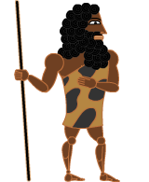  Early Man  This generic “cave man” represents the first human settlers in Israel/Canaan/the Levant. Whoever they were. | 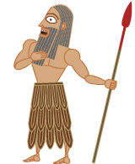  Canaanite  What did ancient Canaanites look like? I don’t know, so this is based on ancient Sumerian art. | 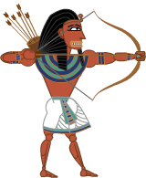  Egyptian  Canaan was located between two huge empires. Egypt controlled it sometimes, and…
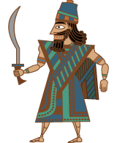  Assyrian  ….Assyria controlled it other times. | 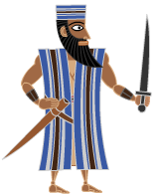  Israelite  The “Children of Israel” conquered this region, according to bloody and violent Old Testament accounts. | 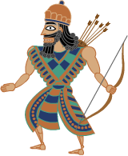  Babylonian  Then the Baylonians destroyed their temple and took the Hebrews into exile.
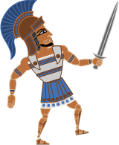  Macedonian/ Greek  Here comes Alexander the Great, conquering everything! | 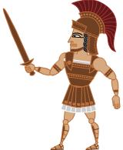  Greek/ Macedonian  No sooner did Alexander conquer everything, than his generals divided it up and fought with each other. | 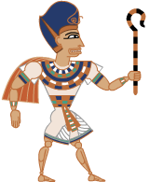  Ptolemaic  Greek descendants of Ptolemy, another of Alexander’s competing generals, ruled Egypt dressed like Egyptian god-kings.
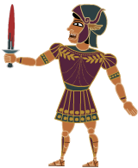  Seleucid  More Greek-Macedonian legacies of Alexander. | 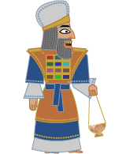  Hebrew Priest  This guy didn’t fight, he just ran the Second Temple re-established by Hebrews in Jerusalem after the Babylonian Exile. | 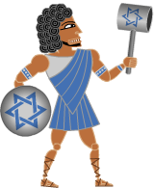  Maccabee  Led by Judah “The Hammer” Maccabee, who fought the Seleucids, saved the Temple, and invented Channukah. Until…

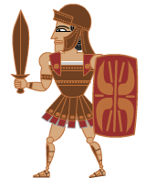  Roman  ….the Romans destroyed the Second Temple and absorbed the region into the Roman Empire… | 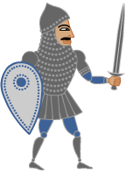  Byzantine  ….which split into Eastern and Western Empires. The eastern part was called the Byzantine Empire. | 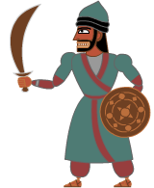  Arab Caliph  Speaking of cartoon, what did an Arab Caliph look like? This was my best guess.
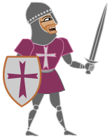  Crusader  After Crusaders went a-killin’ in the name of Jesus Christ, they established Crusader states, most notably the Kingdom of Jerusalem. | 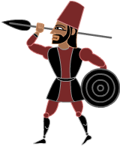  Mamluk of Egypt  They became a powerful military caste in various Muslim societies… And apparently they controlled Palestine for a while. | 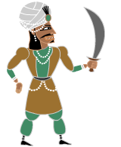  Ottoman Turk  No one went to battle looking like this. But big turbans, rich clothing and jewelry were worn among Ottoman Turkish elites.
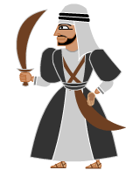  Arab  A gross generalization of a generic 19-century “Arab”. | 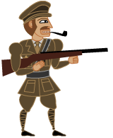  British  The British formed alliances with Arabs, then occupied Palestine. | 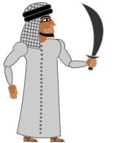  Palestinian  The British occupied this guy’s land, only to leave it to a vast influx of….
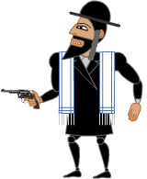  European Jew/Zionist  Desperate and traumatized survivors of European pogroms and death camps, Jewish Zionist settlers were ready to fight to the death for a place to call home, but… | 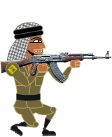  PLO/Hamas/ Hezbollah…. so were the people that lived there. Various militarized resistance movements arose in response to Israel: The Palestinian Liberation Organization, Hamas, and Hezbollah. | 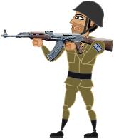  State of Israel  Backed by “the West,” especially the US, they got lots of weapons and the only sanctioned nukes in the region.
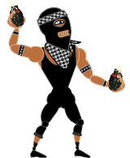  Guerrilla/FreedomFighter/Terrorist  Sometimes people fight in military uniforms, sometimes they don’t. Creeping up alongside are illicit nukes possibly from Iran or elsewhere in the region. Who’s Next? | 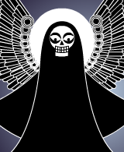  The Angel of Death | What will happen next?

