What is the Golden Age of Islam?

During the Middle Ages, Muslim cities such as Baghdad, Istanbul, Cairo, Tripoli and Cordoba became cultural and intellectual centers where theologians, scholars, scientists, artists, writers, philosophers, mathematicians and others convened for scholarship, experimentation and discovery. The significant achievements made by Muslims from approximately 750 to 1500 A.D. led to the naming of this period as the Islamic Renaissance, or the Islamic Golden Age.
Muslims were at the forefront of discoveries in ophthalmology (study of the human eye), anatomy (study of the human body), physiology (study of the ways in which the bodies of living things work), pathology (the study and diagnosis of disease), surgery, chemistry and pharmaceuticals during the Islamic Renaissance.
Great advances were also made in astronomy and mathematics, as well as in architecture, art and literature. Muslims translated most of the scientific works of antiquity (from ancient Greece, Rome and Egypt) into Arabic. Many of the ancient works were destroyed after the fall of the Roman Empire, because if these translations the great works of Plato, Aristotle, and Socrates were saved.

Arabic words are still used as English scientific terms:
Examples of Arabic words that are now part of scientific English include algebra, algorithm, chemistry, alchemy, zircon, atlas, almanac, earth, monsoon, alcohol, elixir, aorta, pancreas, colon, cornea, diaphragm, and many more!

Arabic Numerals
One of the greatest advances was the introduction of "Arabic" numerals. The "Arabic" numerals were influenced by India's mathematics. It is a system based on place values and a decimal system of tens. These numbers were much easier to use for calculation than the Roman system which used numbers, like I, V, X, L, C, M, etc. Addition, subtraction, multiplication and division now became easy.
With Arabic numerals, simple fractions and decimal fractions were also possible. Fractions and decimal fractions were also described by Muslim mathematicians during the Middle Ages.
Famous Doctors

a.) One of the greatest names in medieval medicine is that of Abu Bakr Muhammad ibn Zakariya' al-Razi, who was born in the Iranian City of Rayy in 865 CE and died in the same town about 925 CE. A physician learned in philosophy as well as music and alchemy, he served at the Samanid court in Central Asia and headed hospitals in Rayy and Baghdad. Al-Razi made the first major Muslim contribution to medicine when he developed treatments for smallpox and measles. He also made significant observations about hay fever, kidney stones, and scabies, and first used opium as an anesthetic (pain killer).

b.) Ibn Sina was one of the greatest physicians in the world, with his most famous book used in European medical schools for centuries. He is credited with discovering the contagious nature of diseases like tuberculosis, which he correctly concluded could be transmitted through the air, and led to the introduction of quarantine (separating sick people from the healthy) as a means of limiting the spread of such infectious diseases.

c.) Abu al-Qasim al-Zahrawi (936–1013 CE), was the "father of modern surgery". He invented and documented more than two hundred surgical instruments. There are approximately 200 drawings of surgical instruments ranging from a tongue depressor and a tooth extractor to a catheter (a small tube for fluids). He wrote extensively about injuries to bones and joints, even mentioning fractures of the nasal (nose) bones and of the vertebrae (spinal bones). In fact, the modern method for fixing a dislocated shoulder was described in At-Tasrif long before it was used by modern doctors! El Zahrawi fully described tonsillectomy (the removal of the tonsils), tracheotomy (creating a breathing hole in the throat) and craniotomy (brain surgery). He performed these operations on corpses (dead bodies). He was also a pioneer in the use of anesthesia (medicine for operations without pain).
Medicine
The world's first observatories (places to watch the skies and stars), public hospitals, psychiatric institutions and universities emerged in the medieval Islamic world.

Hospitals:
While European "hospitals" at this time were usually simply monasteries where the sick were told they would live or die according to God's will, not human intervention, Muslim hospitals pioneered the practices of diagnosis, cure, and future prevention.
The first hospital in the Islamic world was built in Damascus in 707 CE, and soon most major Islamic cities had hospitals, in which hygiene was emphasized and healing was a priority. Hospitals were open 24 hours a day, and many doctors did not charge for their services. Later, a central hospital was established in Baghdad by order of the Abbasid ruler, the first of thirty-four hospitals throughout the Muslim world, many of them with special wards for women. Traveling clinics with adequate supplies of drugs toured the countryside, and others paid regular visits to the jails.
Pharmacies:
Muslims also made advancements in the field of pharmacology (the study of drugs and medicines). They experimented with the medical effects of various herbs and other drugs, and familiarized themselves with anesthetics (pain reliever) used in India. The Arabs established the first drugstores and wrote the first encyclopedias of drugs and medicines. The first pharmacies were established in Baghdad in the 8th century. Baghdad had at one time as many as eight hundred sixty two registered pharmacists, all of whom had passed formal examinations.

Education:
The world's oldest degree-issuing university, Al-Karaouine, was established in Fez in 859 CE and the first full university, Al Azhar, opened in Cairo in 975 CE. The medical school at the University of Jundishapur, once the capital of Sassanid Persia, became the largest in the Islamic world by the 9th century. Its location in Central Asia allowed it to incorporate medical practices from Greece, China, and India, as well as developing new techniques and theories.
Scientific Inventions
Agriculture/Irrigation:
For centuries, the dry and harsh environment of much of the Muslim lands made the collection, transportation, and storage of water important. It is hardly surprising that the most important progress in medieval Muslim technology and engineering was achieved in relation to water.
In the tenth century al-Kindi proposed a plan to dam the Nile. A dam is a structure which blocks the flow of water in a river. Dams block water from flowing down the river and can be used to make lakes of extra water so that a town will never run out of water. Many of the dams, reservoirs, and aqueducts constructed at this time throughout the Islamic world still survive.
Muslim engineers also perfected the waterwheel and built underground water channels some fifty feet underground. The underground channels had manholes (openings from the street) so that they could be cleaned and repaired.

Astronomy:
Muslims built the first observatory as a scientific institution in the 13th century. They used these to study the movements of the stars and other heavenly bodies.
The astrolabe allowed people to find their precise latitude by using the position of the stars. The astrolabe was later modified to be used on ships. This innovation allowed Europeans to begin exploring the seas more safely. This lead to the Europeans finding faster trade routes to Asia by sea and Christopher Columbus’s “discovery” of the New World.

Arts & Literature
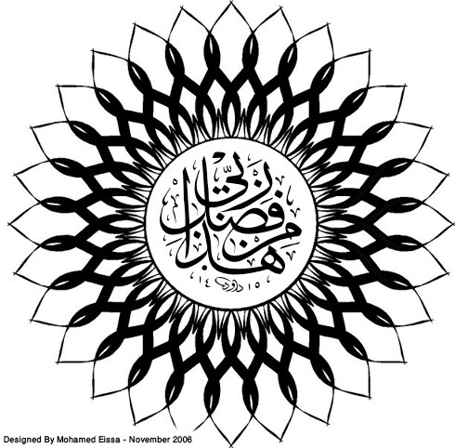
Art:
According to the teachings of the Qur'an, Islamic artists
were forbidden from using human figures in religious art. Therefore, they developed a style of geometric shapes and patterns that were used to decorate religious buildings called Mosques. These geometric patterns usually contained verses from the Qur'an written in a stylized form of decorative handwriting called calligraphy.

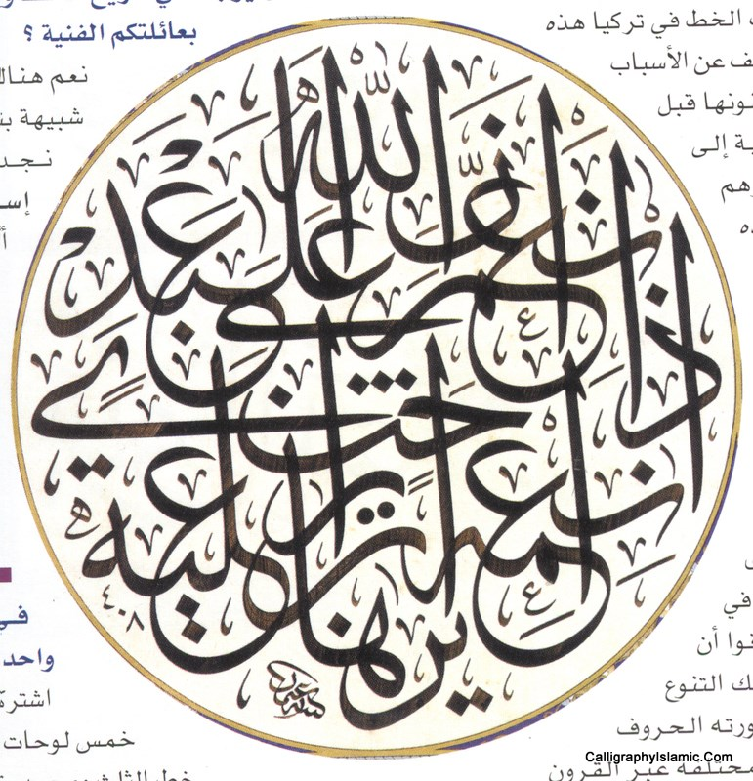
Non-religious artists were allowed to use human figures. This type of work most often appears in scholarly works of science or literature, which were lavishly illustrated.

Architecture:
Islamic architects borrowed heavily from the Byzantine Empire which used domes and arches extensively throughout their cities. An example of this use can be seen in the Dome of the Rock, a famous mosque in Jerusalem.

Literature:
There were many different styles of Islamic literature. Most works were based on the Qur'an, but some Islamic artists wrote poetry about the joys and sorrows of love. Also, stories from other cultures were adapted and rewritten for Islamic civilization. The most famous collection is called The Thousand and One Nights, which is a collection of tales that includes such well known stories as Aladdin and His Magic Lamp.

The Decline of the Golden Age:
As the empire grew, it became more and more difficult to control. Eventually the government could no longer protect all the reaches of land of the Islamic empires. During this same period, the European Crusades (1097-1291) weakened the Islamic Empires' powers from without. Cordoba fell to Spanish Christians in 1236. When the Mongols sacked Baghdad in 1256 the Islamic Empire never recovered. Trade routes became unsafe. Urban life broke down.

‐Golden Age of Islam Student Notes Sheet- Name: ________________________ Period: ____
Arabic Numerals (numbers)
Why are Arabic Numerals easier to use than Roman Numerals?

Famous Doctors
Give at least two achievements of Abu Bakr Muhammad ibn Zakariya' al-Razi:

Give at least two achievements of Ibn Sina:

Give at least two achievements of Abu al-Qasim al-Zahrawi:

Medicine
How are ancient Muslim hospitals similar to hospitals today?

How are they different?

Describe the Islamic pharmacies:

The world's oldest degree-issuing university, _______________, was established in Fez in 859 CE and the first full university, ________________, opened in Cairo in 975 CE.

Why was the medical school at the University of Jundishapur so important for spreading new ideas in medicine? Think about geography.

Scientific Inventions
List and describe 5 agricultural or irrigation innovations:

Astronomy:
What is an astrolabe?

What would life be like if Europeans had never “discovered” the New World?

Arts and Literature
According to the teachings of the Qur'an, Islamic artists were forbidden from using _____________________ in religious art. Therefore, they developed a style of ___________________ shapes and patterns that were used to decorate religious buildings called ____________________. These geometric patterns usually contained verses from the Qur'an written in a stylized form of decorative handwriting called __________________.

Architecture:
Islamic architects borrowed heavily from the Byzantine Empire which used ______________ and arches extensively throughout their cities. An example of this use can be seen in the _______________________, a famous mosque in Jerusalem.

Literature:
There were many different styles of Islamic literature. Most works were based on the _______________, but some Islamic artists wrote poetry about the joys and sorrows of love. Also, stories from other cultures were adapted and rewritten for Islamic civilization. The most famous collection is called _________________________, which is a collection of tales that includes such well known stories as __________________________________.

