Unit 2: Middle Ages Study Guide
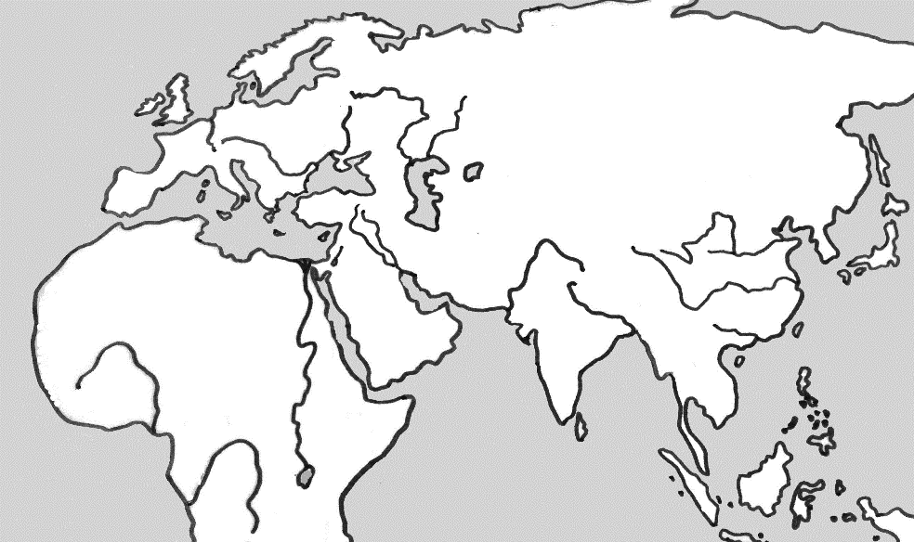
- Shade in these empires:
  - Mongol Empire
Roman
Mongol
  - Holy Roman Empire
b
  - Islamic Empire
a
Islamic
c
- Mark these cities:
- Jerusalem
- Constantinople/Istanbul
- Timbuktu

- Name some areas of achievements during the Golden Age of Islam?
Advances in math, science, medicine – preserved Greek and Roman learning
- Muhammad was the Middle Eastern founder of what religion? Islam
- What peasant girl helped lead France to victory in the 100 year War? Joan of Arc
- This Mongolian leader conquered the largest land empire in history? Genghis Khan
- This man traveled to China, lived there and worked for Kublai Khan, and then came back to Italy and wrote an eye opening book which inspired many people to also travel and trade?
Marco Polo
- When medieval farmers invented new tools and methods what happened to the population?
More food meant more people were born
- What is a guild?
Association that helps workers at their profession, trains new members as apprentices
- How did most African civilizations pass on information and education?
Oral and musical tradition
- This empire held land that bordered three different continents, making cultural diffusion very easy?
Islamic Empire
- Name the trade route that helped the Mongolian Empire become wealthy because they controlled it?
Silk Road
- Bushido, or the way of the warrior, was followed by what Japanese group of people?
Samurai
- In Japanese feudal society this person was at the top, although they had no real power?
Emperor
- Islamic centers of learning sprang up in Africa during the middle ages because of trading in these two items? Salt and gold
- What rich Muslim created the Islamic university of Timbuktu?
Mansa Musa
- Justinian law code and the Hagia Sophia were created by leaders of this empire?
Byzantine Empire
- This Mughal leader tried to strengthen his empire by blending religions together?
Akbar the Great
- One of the Five Pillars of Islam is the hajj (religious journey) to this important Saudi Arabian city?
Mecca
- The Magna Carta took power away from the king, but also gave all freemen the right to what?
Have a trial by a jury of their peers
- This Byzantine emperor codified Roman laws, an important legal step forward?
Justinian
- The Great Schism meant that we had two churches; the Catholic Church was part of the Holy Roman Empire and this church was part of the Byzantine Empire?
Eastern Orthodox Church
- Overthrowing Muslim expansion and taking back Jerusalem were the objectives of what religious wars?
Crusades
- What important city was at the crossroads between Asia and Europe?
Constantinople
- King John of England abused his power and the nobles made him sign this important document?
Magna Carta
- 1/3 of the people in Europe and Asia died as a result of this event?
Plague or Black Death
- Feudalism replaced the centralized power of Europe when this Empire fell.
Roman Empire
- What institution held great power in the middle ages?
Catholic Church
- In order to get protection from attackers many city dwellers moved to a place where farming and being self-sufficient were part of life. They moved to a Manor.

- Complete the social class pyramid for the middle ages in Europe.
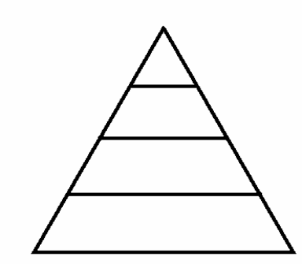
King
Lord
Knights
Peasants/Serfs

- The code of conduct for Knights was called what?
Chivalry
- What were Knights given in exchange for their military service to lords?
Land
- Feudalism started because this group of people were constantly attacking European cities?
Vikings
- The main job of a vassal was to serve his Lord.
- Why was Charlemagne a favorite of the Pope?
Converted his empire to Christianity
- After Jesus died, this person traveled through the Roman Empire spreading the Christian religion?
Paul
- What was the end result of the 100 Year War?
France wins and England never comes back to claim European land
- When Muslims conquered North Africa this became the dominant language? Arabic

Essay Questions - Academic Students will do essay question ONE, and then any other question (total of two)
Honors students will complete ALL FOUR questions.

1. Analyze the factors that led to the creation of feudalism and the manor system?
Due to the dangerous conditions in western Europe after the fall of Rome, feudalism became the accepted political system. Centered around protection, this decentralized system provided lords granted fiefs to vassals in return for service and taxes. The many groups, like Vandals, Muslims, and Vikings made Europe quite dangerous in the early middle ages. The economic system, manorialism, was based on self-sufficiency, another by-product of the need for protection. All economic activity was centered in and around the castle manor, so that travel was not needed. As a result of this emphasis on protection and safety, trade in the early middle ages was almost non-existent.

2. Organize the information below about Judaism and Islam by using the chart format.
Judaism Islam
Founder | Abraham | Muhammad
Where was it founded? | Israel | Middle East/ Saudi Arabia
Sacred Text | Torah | Koran
Holiday | Hanukkah | Ramadan
Two basic beliefs | Monotheistic – God  Ten Commandments | Monotheistic – Allah  Five Pillars

3. Do you agree that the Church became a powerful unifying force in Medieval Europe? Explain your response.
Yes, the Church did become a powerful unifying force in Medieval Europe. More than any other institution, it unified Europeans and gave every person a sense of how the world worked. Since political leaders only had local power, the Church was the most powerful institution. In a time of great political chaos, the Roman Catholic Church was the single, largest structure in medieval Europe. While the diverse kingdoms lacked a common language or government, they shared a common Christian culture. There was a church in every village across Europe. It touched everyone's life, no matter what their rank or class or where they lived. Everyone in Europe was a Christian during the Middle Ages from the richest king down to the lowest serf.

