Unit 1 Test Study Guide Review

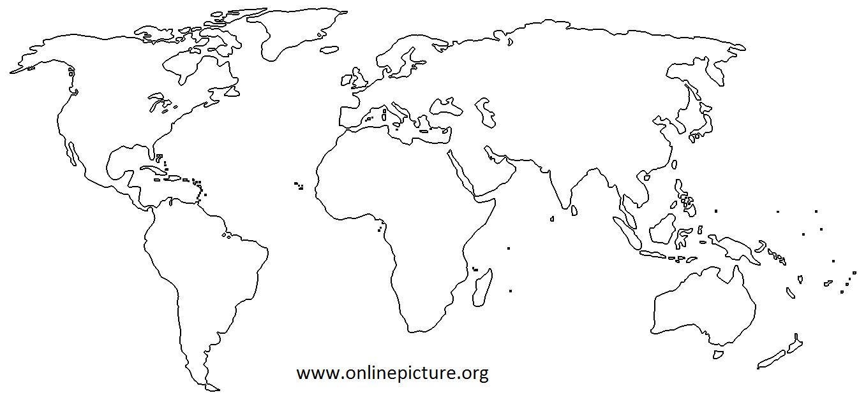

1. Label the 6 continents shown and 4 oceans.
North America, South America, Europe, Asia, Africa, Antarctica, Australia – Pacific, Atlantic, Indian, Arctic

2. Label the 4 early river valley civilizations of India, Egypt, Mesopotamia, and China

- What new idea of government did the Athenians create? _____________________________.

- Name the 6 characteristics of a civilization.

- What is polytheism?

- Who has the power in an oligarchy?

- Why were Egyptian kings buried in pyramid tombs?

- Who are the three most famous Greek philosophers?

- This Athenian leader introduced the idea of giving citizens the right to vote directly on laws. _____________________

- The belief that the gods gave Chinese leaders the right to rule is called the _____________________________.

- What type of government is it when citizens elect representatives to make decisions for them? ___________________

- Name the three main participants that fought in the Persian War.

- Hellenism, or the spreading of Greek culture, was done the most by this great leader? _________________________

- Major cities developed along this ancient trade route that stretched from China to Europe? ______________________

- Name the war that weakened Greece and led to its downfall? ______________________________________

- The 200 years of relative peace and prosperity during the Roman Empire was known as _________________________.

- Early villages were able to grow their population because they had more than enough food to feed, which is called what?

- Spreading ideas through warfare, trade, and migration is an example of ______________________________________.

- What is the main reason that early civilizations developed along rivers?

- During the ___________________ ___________________ we went from hunting and food gathering to farming, which led to the creation of permanent settlements.

- Name the king that took his laws, applied them to everyone (but had different punishments), wrote them down, and put them on giant tablets for all to see.

- What group of people were “outcastes” in Ancient India? ____________________________

- Why did the early Greeks have to trade, colonize, and fish to get enough food?

- In some ancient civilizations, like India, if you were born a farmer then your children have no choice and would be farmers also. That’s because they have a ___________________ ___________________ that doesn’t allow any movement or change.

- How were the early Indus Valley cities different than the other river valley civilizations?

- These Roman laws, called the _____________________________, were publicly displayed and applied to everyone.

- During the Neolithic Revolution, why were some people able to stop farming and specialize in other jobs?

- This ancient civilization contributed to Western European culture by promoting the idea of having a government by laws?

- Why have Indian people depended on monsoons throughout history?

- What are some accomplishments of Emperor Qin Shi Huangdi?

- Art and architecture generally reflect the _____________________ of a society.

- Two forms of early ancient writing:
Sumeria created __________________________, and Egypt created ____________________________

Essay Question Topics

1. Be able to explain how geography influenced the development of any two of the early civilizations.

2. Explain what Hammurabi’s Code is, how it worked, and whether you think it would be effective in the United States.

3. Compare and contrast the city-states of Athens and Sparta through government, military, gender roles, and values.

