Unit 1 Test Review Answers

1.
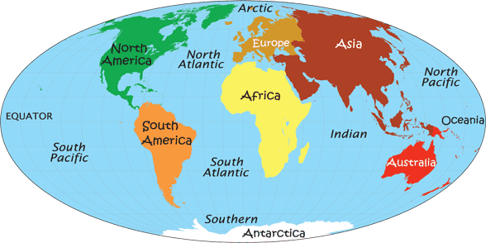

2.
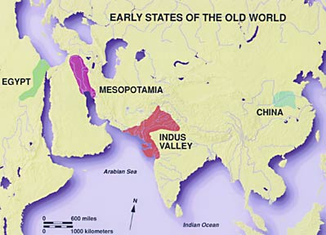

3. Democracy
4. cities, government, religion, social structure, writing, culture
5. belief in many gods
6. small group of elites
7. belief in afterlife, take possessions with them, be remembered for greatness
8. Socrates, Plato, Aristotle
9. Pericles
10. Mandate of Heaven
11. Republic
12. Spartans, Athenians, Persians
13. Alexander the Great
14. Silk Road
15. Peloponnesian War
16. Pax Romana
17. surplus
18. cultural diffusion
19. water to irrigate crops
20. Neolithic Revolution
21. Hammurabi
22. Untouchables (Dalit)
23. not enough farmland, tough geography
24. class system
25. planned cities that showed technology like sewers
26. written and posted
27. they had a surplus of food
28. Romans
29. weather system that waters the crops
30. Great Wall of China, set weights and measures, made money, Terra Cotta Army
31. values
32. cuneiform, hieroglyphics

Essay Help

1. Choose two civilizations, like Greece and China, and explain what the geography was and how this made them develop. Example: Greece learned to use boats to colonize, trade, and fish because of a lack of farmland, and city-states developed because of mountains. China developed independently because they were isolated by mountains, rivers, and deserts.

2. First important set of written laws that applied to all, but different punishments based on class. The King used them to unify his Babylonian Empire and put them on “stele” or stone slabs at the entrance to his cities. They are very harsh so it might get people to stop committing crime, but many Americans would find unfair.

3. Athens Sparta
Government | Democracy | Oligarchy, monarchy
Military | Great navy | Military society, trained from 7 years old to fight
Gender Roles | Both girls and boys educated, women had some rights | Women physically fit to have babies, ran Sparta when husbands were off at war, respected
Values | Valued education, democracy and philosophy | Valued strength, toughness, war

