World History Final Exam Study Guide

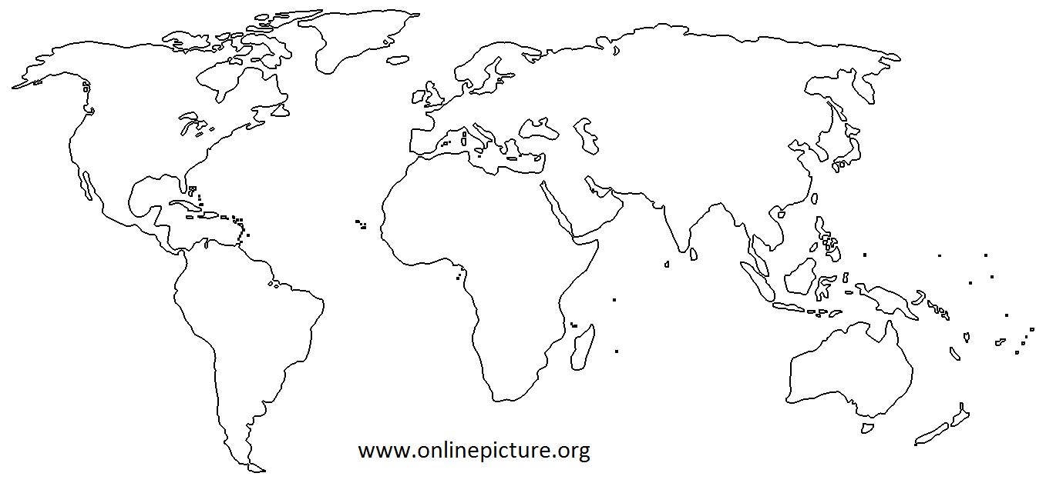

1. Label the 6 continents shown and the 4 major oceans.

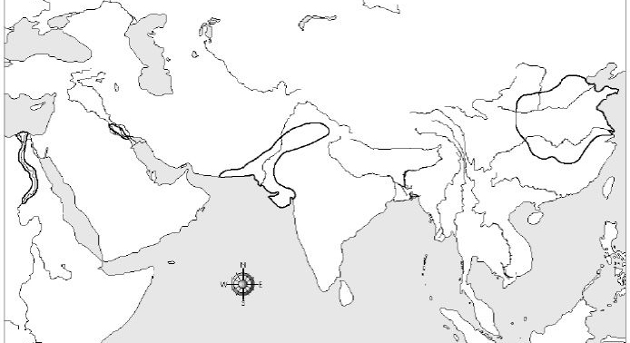
2. Identify the early river civilizations that developed along the Indus River, the Nile River, The Tigris and Euphrates Rivers, and the Huang He (Yellow) and Yangtze Rivers.
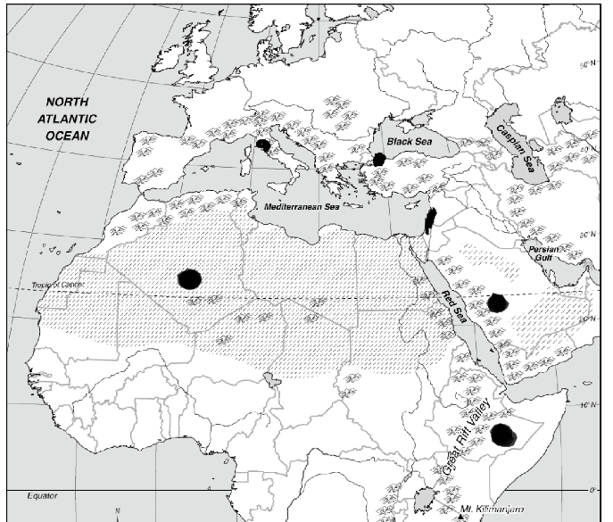

3. Label the cities of Timbuktu, Constantinople/Istanbul, and Jerusalem?

4. Some characteristics of civilization are: social structure, culture, religion, writing, art, cities.

5. Aristotle, Socrates, and Plato were famous Greek philosophers that encouraged questioning of the world around them.

6. The Mandate of Heaven, in China, was the belief that the gods gave dynasties permission to rule.

7. A republic is the type of government that involves citizens electing representatives to govern for them.

8. Migration, trade, and warfare all lead to the mixing of new ideas and goods which is called cultural diffusion.

9. The first time a state’s laws were set down in writing was in Hammurabi’s Code.

10. Many cities were established within major empires because of the Asia to Europe trade route called the Silk Road.

11. Brahmin, Kshatriya, and Untouchables are all part of the social hierarchy associated with cultures from India.

12. The Neolithic Revolution created one of the greatest economic shifts in human history and led to the establishment of permanent settlements.

13. During the middle ages, the Church decided who would go to heaven and achieve salvation.

14. Serving his lord was part of the feudal contract of a vassal.

15. One third of the people of Europe died from a virus called the plague or Black Death.

16. During feudalism the order of power went from the King to the nobles, to the knights, to the peasants.

17. Ghana, Mali, and Songhai had control of gold-salt trade routes and become large and powerful West African kingdoms.

18. Japanese samurai followed bushido, or a strict warrior code.

19. The Mongols, led by Genghis Khan, created the largest land empire in history.

20. Feudalism developed as a way for medieval societies to protect themselves.

21. Chivalry was a code of conduct for knights.

22. Jerusalem was captured by Christian knights during the First Crusade.

23. The Justinian Code, the Hippodrome, and the Hagia Sophia were all achievements of the Byzantine Empire.

24. Muhammad emerged from the Middle East and unified local tribes with a new religion called Islam.

25. Leonardo da Vinci was a painter, sculptor, architect, inventor, and mathematician. He was an Italian who was a great example of a Renaissance man.

26. The time period when a renewed interest in classical learning and the arts was called the Renaissance.

27. The Renaissance contributed to the Age of Exploration because they wanted to discover and innovate.

28. During the Renaissance, humanists were inspired by classical texts and emphasized the dignity and worth of the individual.

29. Johann Gutenberg’s invention, the printing press, meant more people learned to read.

30. Martin Luther began the Protestant Reformation when his 95 theses created controversy across Europe.

31. Henry the 8th founded the Anglican Church when the Pope refused to annul his marriage.

32. Martin Luther was eventually excommunicated by the Catholic Church.

33. Colonialism is when a nation sends settlers to govern new lands that were sometimes thousands of miles away.

34. Europeans brought a lot of diseases to the New World through the Columbian Exchange.

35. The reasons for exploration were Gold, God, and Glory.

36. During the early period of Spanish colonialism in the New World they needed to import slaves because so many natives died.

37. The economic system that develops in Europe and depends on a nation maintaining a favorable balance of trade is mercantilism.

38. Africans were a better source of labor than Native Americans because of disease immunity, experience, and had no places to hide or escape to.

39. Guns and money were brought from Europe to Africa on one leg of the triangular trade.

40. Life, liberty, and property were all natural rights written about by John Locke.

41. The Storming of the Bastille was the official start of the French Revolution

42. The idea that kings receive their power from God and are responsible only is called the divine right of kings.

43. Toussaint L’Overture helped create the first black democracy in Haiti.

44. Thomas Hobbes’ believed that people should hand over their rights to a ruler in exchange for law and order because he supported absolutism.

45. Colonists in North America were angry at the British government for taxation without representation.

46. Prior to the Scientific Revolution, the Church taught that the Earth was the center of the universe.

47. After the fall of Napoleon the Congress of Vienna redrew the map of Europe.

48. The Scientific Revolution laid the foundation for the Enlightenment because it introduced the idea of reason.

49. Absolutism is when a king or queen has complete power over a country.

50. The guillotine was the preferred method of execution during the Reign of Terror within the French Revolution.

51. A major idea of the Enlightenment was that citizens are born free and equal with certain guaranteed rights.

52. The textile industry was the first to change as a result of the Industrial Revolution.

53. The steam engine replaced the water frame and allowed factories to move away from rivers.

54. The Industrial Revolution began in Britain because they had capital and natural resources.

55. Urbanization is when people move from rural areas to cities.

56. Many farmers lost their land and had to move to the city as a result of the enclosure movement.

57. During the Industrial Revolution we saw an increase in the mass-production of goods.

58. Women and children were paid a lot less than men during the Industrial Revolution.

59. Social Darwinism is the idea that westerners had a duty to bring their culture and civilization to the inferior races of the world.

60. The Sepoy Rebellion started in India and the Boxer Rebellion started in China.

61. European nations sought colonies because they were competing for raw materials and markets.

62. Imperialism is when you conquer other lands, make them into colonies, and control their economies.

63. The causes of World War One were militarism, alliances, nationalism, and imperialism.

64. The spark that ignited World War One was the assassination of Archduke Ferdinand.

65. World War One was mostly fought using trench warfare

66. An armistice is an agreement to stop fighting, and a treaty is an official end to the war.

67. Great Britain, France, the USA, and Russia were all Allies during World War One.

68. The Treaty of Versailles punished Germany for starting World War One by taking territory, reducing their military, and forcing them to pay reparations.

69. American casualties in World War One were very low since we got into the war very late.

70. World War One is considered the first war with modern weapons, which is why the death toll was very high.

71. Propaganda is used to shape public opinion.

72. World War I was a “total war” because the nations involved devoted all their resources to it.

73. Bank failures, high unemployment, and the stock market crashing were all reasons for the Great Depression that hit after World War One.

74. During World War Two the leader of Germany was Hitler, Mussolini in Italy, Churchill in England, and Roosevelt from the United States.

75. The European powers practiced appeasement when Hitler’s violated the Treaty of Versailles.

76. After the bombing of Pearl Harbor, the United States declare war in World War Two.

77. Great Britain, the United States, and the Soviet Union were the Allied Power during World War Two.

78. The largest invasion battle in history was called D-Day, when Allied forces stormed the beaches of Normandy in World War Two.

79. The United States dropped the only atomic bombs ever on the cities of Hiroshima and Nagasaki.

80. The United Nations was formed after World War Two as a peacekeeping organization.

81. The global political battle between the Soviet Union and the United States was called the Cold War.

82. The United States sent troops to Vietnam and Korea because they were afraid that if Communism took hold it would spread to the neighboring countries, which was called the domino theory.

83. Rather than defeating communism in countries where it already existed during the Cold War, the United States tried to stop it from spreading. This was known as containment.

84. One of the main reasons for global warming is air pollution.

85. When members of the same nation fight each other it’s called a civil war.

86. Terrorists create panic by breaking basic rules of society and attempting to destroy the social systems of target countries.

87. After a Cold War battle with the Soviet Union, and then a civil war, the Taliban took over in Afghanistan as the ruling party.

88. Peace talks between Israel and Palestine are always difficult because they can never agree on Jerusalem, which they both see as their own holy city.

89. Apartheid is the segregated system that the whites in South Africa instituted in order to maintain their power.

90. Genocide is the deliberate and systematic extermination of a national, racial, political, or cultural group.

Essay Question

Goods and ideas have moved from one place to another for a variety of reasons. The changes that resulted from the movement of these goods and ideas to new places significantly influenced groups of people, societies, and regions.

Select TWO goods and/or ideas that moved from one place to another and for each
• Explain how this good or idea moved from one place to another
• Discuss how the movement of this good or idea significantly influenced a group of people, a society, and/or a region

