World History Final Exam Study Guide

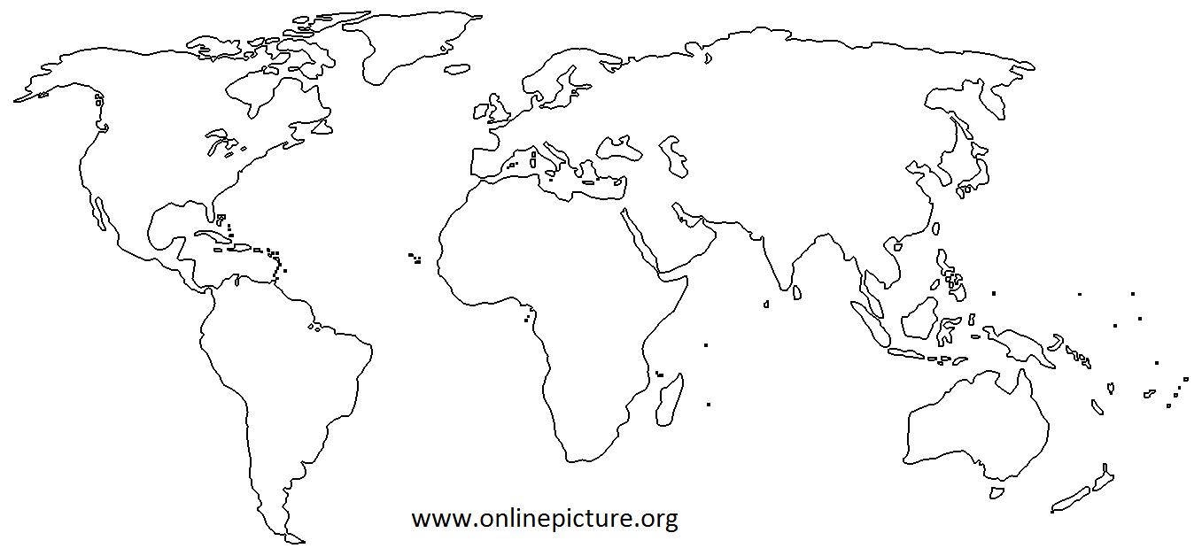

1. Label the 6 continents shown and the 4 major oceans.

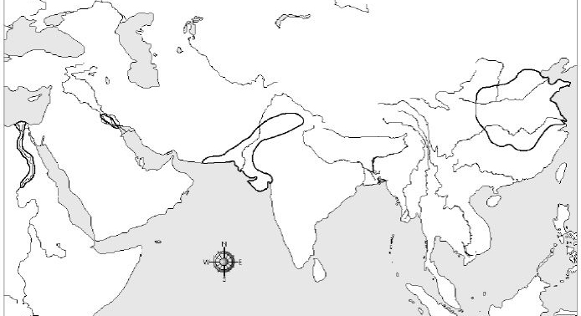

2. Identify the early river civilizations that developed along the Indus River, the Nile River, The Tigris and Euphrates Rivers, and the Huang He (Yellow) and Yangtze Rivers.

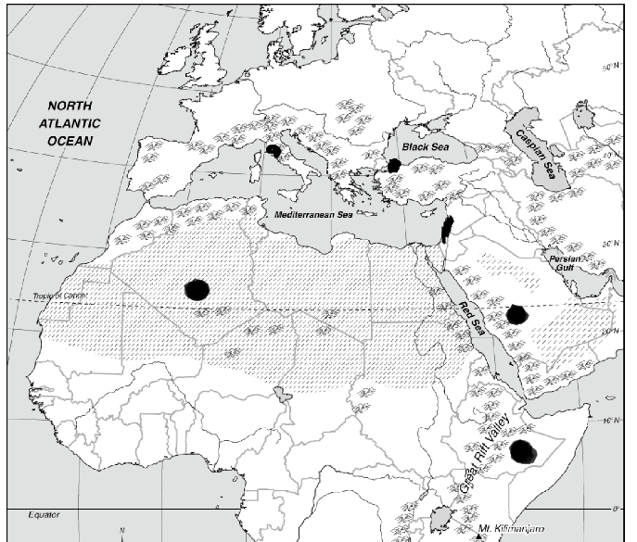

3. Label the cities of Timbuktu, Constantinople/Istanbul, and Jerusalem?

4. Some characteristics of civilization are: social structure, culture, ___________________, ___________________, art, and cities.

5. ___________________, Socrates, and ___________________ were famous Greek philosophers that encouraged questioning of the world around them.

6. The ___________________ of ___________________, in China, was the belief that the gods gave dynasties permission to rule.

7. A ___________________ is the type of government that involves citizens electing representatives to govern for them.

8. Migration, trade, and warfare all lead to the mixing of new ideas and goods which is called cultural ___________________.

9. The first time a state’s laws were set down in writing was in ___________________’s Code.

10. Many cities were established within major empires because of the Asia to Europe trade route called the ___________________

11. Brahmin, Kshatriya, and Untouchables are all part of the social hierarchy associated with cultures from ___________________.

12. The ___________________ Revolution created one of the greatest economic shifts in human history and led to the establishment of permanent settlements.

13. During the middle ages, the ___________________ decided who would go to heaven and achieve salvation.

14. Serving his lord was part of the feudal contract of a ___________________.

15. One third of the people of Europe died from a virus called the plague or ___________________.

16. During feudalism the order of power went from the King to the nobles, to the ___________________, to the peasants.

17. Ghana, ___________________, and Songhai had control of gold-salt trade routes and become large and powerful West African kingdoms.

18. Japanese samurai followed ___________________, or a strict warrior code.

19. The ___________________, led by Genghis Khan, created the largest land empire in history.

20. Feudalism developed as a way for medieval societies to ___________________ themselves.

21. ___________________was a code of conduct for knights.

22. The city of ___________________was captured by Christian knights during the First Crusade.

23. The Justinian Code, the Hippodrome, and the Hagia Sophia were all achievements of the ___________________ Empire.

24. Muhammad emerged from the Middle East and unified local tribes with a new religion called ___________________.

25. ___________________was a painter, sculptor, architect, inventor, and mathematician. He was an Italian who was a great example of a Renaissance man.

26. The time period when a renewed interest in classical learning and the arts was called the ___________________.

27. The Renaissance contributed to the Age of ___________________ because they wanted to discover and innovate.

28. During the Renaissance, ___________________ were inspired by classical texts and emphasized the dignity and worth of the individual.

29. ___________________’s invention, the printing press, meant more people learned to read.

30. ___________________began the Protestant Reformation when his 95 theses created controversy across Europe.

31. Henry the 8th founded the ________________ Church when the Pope refused to annul his marriage.

32. Martin Luther was eventually ___________________ by the Catholic Church.

33. ___________________ is when a nation sends settlers to govern new lands that were sometimes thousands of miles away.

34. Europeans brought a lot of deadly ___________________ to the New World through the Columbian Exchange.

35. The reasons for exploration were _______________, ________________, and ________________.

36. During the early period of Spanish colonialism in the New World, they needed to import ___________________ because so many natives died.

37. The economic system that develops in Europe and depends on a nation maintaining a favorable balance of trade is ___________________.

38. Africans were a better source of labor than Native Americans because of disease ___________________, experience, and had no places to hide or escape to.

39. _________ and ___________ were brought from Europe to Africa on one leg of the triangular trade.

40. Life, liberty, and property were all natural rights written about by ___________________.

41. The Storming of the ___________________ was the official start of the French Revolution.

42. The idea that kings receive their power from God and are responsible only is called the ___________________right of kings.

43. Toussaint L’Overture helped create the first black democracy in ___________________.

44. Thomas Hobbes’ believed that people should hand over their rights to a ruler in exchange for law and order because he supported ___________________.

45. Colonists in North America were angry at the British government for ___________________ without representation.

46. Prior to the Scientific Revolution, the Church taught that the ___________________ was the center of the universe.

47. After the fall of Napoleon the Congress of ___________________ redrew the map of Europe.

48. The Scientific Revolution laid the foundation for the Enlightenment because it introduced the idea of ___________________.

49. ___________________is when a king or queen has complete power over a country.

50. The ___________________was the preferred method of execution during the Reign of Terror within the French Revolution.

51. A major idea of the ___________________was that citizens are born free and equal with certain guaranteed rights.

52. The ___________________industry was the first to change as a result of the Industrial Revolution.

53. The steam engine replaced the ___________ ____________and allowed factories to move away from rivers.

54. The Industrial Revolution began in Britain because they had _______________and natural resources.

55. ___________________is when people move from rural areas to cities.

56. Many farmers lost their land and had to move to the city as a result of the ___________________movement.

57. During the _____________ ________________we saw an increase in the mass-production of goods.

58. ___________________and children were paid a lot less than men during the Industrial Revolution.

59. ________________________ is the idea that westerners had a duty to bring their culture and civilization to the inferior races of the world.

60. The _______________Rebellion started in India and the _____________Rebellion started in China.

61. European nations sought __________________ because they were competing for raw materials and markets.

62. ___________________ is when you conquer other lands, make them into colonies, and control their economies.

63. The causes of World War One were _________________, _________________, nationalism, and imperialism.

64. The spark that ignited World War __________ was the assassination of Archduke Ferdinand.

65. World War One was mostly fought using ___________________ warfare.

66. An _____________ is an agreement to stop fighting, and a ___________ is an official end to the war.

67. Great Britain, ______________, the USA, and _____________ were all Allies during World War One.

68. The Treaty of ___________________ punished Germany for starting World War One by taking territory, reducing their military, and forcing them to pay ___________________.

69. American casualties in World War One were very ___________ since we got into the war very late.

70. World War One is considered the first war with ________________ weapons, which is why the death toll was very high.

71. ___________________ is used to shape public opinion.

72. World War One was a “___________ ________” because the nations involved devoted all their resources to it.

73. Bank failures, high unemployment, and the __________ ___________ crashing were all reasons for the Great ___________________ that hit after World War One.

74. During World War Two the leader of Germany was ___________________, Mussolini in Italy, Churchill in ___________________, and Roosevelt from the United States.

75. The European powers practiced __________________ when Hitler violated the Treaty of Versailles.

76. After the bombing of ___________ ___________, the United States declare war in World War Two.

77. Great Britain, the United States, and the ___________ ___________ were the Allied Power during World War Two.

78. The largest invasion battle in history was called ___________________, when Allied forces stormed the beaches of Normandy in World War Two.

79. The United States dropped the only ___________ _________ ever on the cities of Hiroshima and Nagasaki.

80. The _______________ _______________ was formed after World War Two as a peacekeeping organization.

81. The global political battle between the Soviet Union and the United States was called the ________ ___________.

82. The United States sent troops to ___________________and ___________________ because they were afraid that if Communism took hold it would spread to the neighboring countries, which was called the domino theory.

83. Rather than defeating communism in countries where it already existed during the Cold War, the United States tried to stop it from spreading. This was known as ___________________.

84. One of the main reasons for ___________________ ___________________ is air pollution.

85. When members of the same nation fight each other it’s called a ___________________ war.

86. ___________________ create panic by breaking basic rules of society and attempting to destroy the social systems of target countries.

87. After a Cold War battle with the Soviet Union, and then a civil war, the ___________________ took over in Afghanistan as the ruling party.

88. Peace talks between Israel and Palestine are always difficult because they can never agree on ___________________, which they both see as their own holy city.

89. ___________________ is the segregated system that the whites in South Africa instituted in order to maintain their power.

90. ___________________ is the deliberate and systematic extermination of a national, racial, political, or cultural group.

Essay Question

Goods and ideas have moved from one place to another for a variety of reasons. The changes that resulted from the movement of these goods and ideas to new places significantly influenced groups of people, societies, and regions.

Select TWO goods and/or ideas that moved from one place to another and for each
• Explain how this good or idea moved from one place to another
• Discuss how the movement of this good or idea significantly influenced a group of people, a society, and/or a region

