Journal: Scientific Revolution

1. What if you were told your whole life that something was a certain way, but then found out it was a lie, and the people that told you knew the whole time? Would you trust them again? Why or why not?
2. What happened when you found out the tooth fairy or Santa Claus (sorry if you didn’t know) wasn’t real? How did you react?

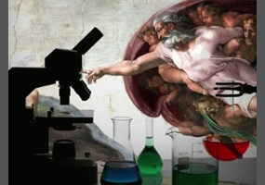

Exit Ticket:
3. Imagine the future in your mind. Think about the things you would want to have that don’t exist yet, or aren’t good enough for everyone to use. Go on the internet and do some quick research about a new field of study, invention, or discovery that might change the world. Find something cool that is a real possibility.

