Notes on Roman Civilization
I. The Roman Republic
A. Rome began as a ________________________ that was heavily influenced by ________________ culture.
B. By 509 B.C., Rome was ruled by elected _________________ who served in the Roman Republic
1. During the Republic, Rome expanded by defeating __________________________ in the Punic Wars & later under generals like _________________________________
2. But, the Republic weakened due to corruption, ___________________________, & the assassination of Julius Caesar in 44 B.C.

II. The Roman Empire
A. After Caesar’s __________________________, Rome became an empire ruled by the Emperor __________________________
B. Under Augustus, Rome entered an era of ____________ & __________________ known as the Pax Romana
C. After 207 years of prosperity during the _________________________________, the Empire began to decline & was conquered in 476 A.D.

III. The Decline of the Roman Empire
A. The Fall of the Roman Empire happened in 3 major stages:
1. An era of decline due to internal problems within Rome

a. The Romans experienced _____________________ problems
i. The empire was too ___________ for one emperor to control
ii. Emperors after the Pax Romana were _______________
iii. Citizens experienced a loss of confidence, patriotism, & _____________ to the Roman gov’t

b. The Romans experienced ______________________ problems
i. Outside groups disrupted _______________
ii. Poor harvests led to ______________ shortages
iii. Rome had a trade imbalance (they _____________________ more than they produced)
iv. The gov’t raised ________________ & printed new coins which led to __________________.
v. The economic decline left many Romans _________________

c. The Romans experienced _______________________ problems
i. Germanic tribes outside Rome were gaining strength
ii. The Roman military was growing weak: __________________ were challenging the authority of the emperors
iii. To save __________, Romans hired foreign soldiers but these “___________________________” were not loyal to Rome

IV. The Classical Era
A. The civilizations of the ______________________ Era produced important achievements that are still used today
B. The combination of Greek & Roman achievements are known as ________________________ culture
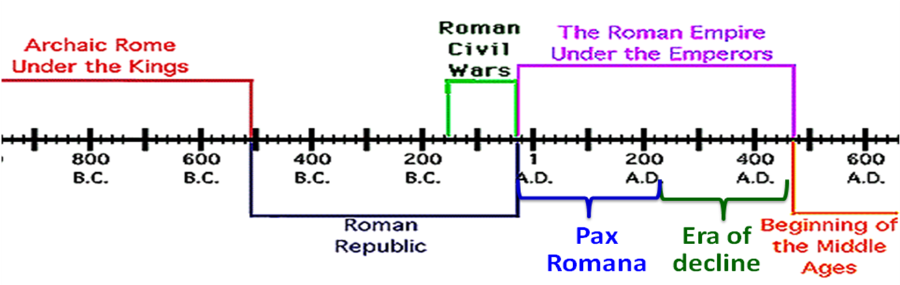

Journal Answers

