Monday Gladiator Journal
Imagine that you are the leader of the United States, and just like the leaders of Ancient Rome, you are expected to entertain the masses.
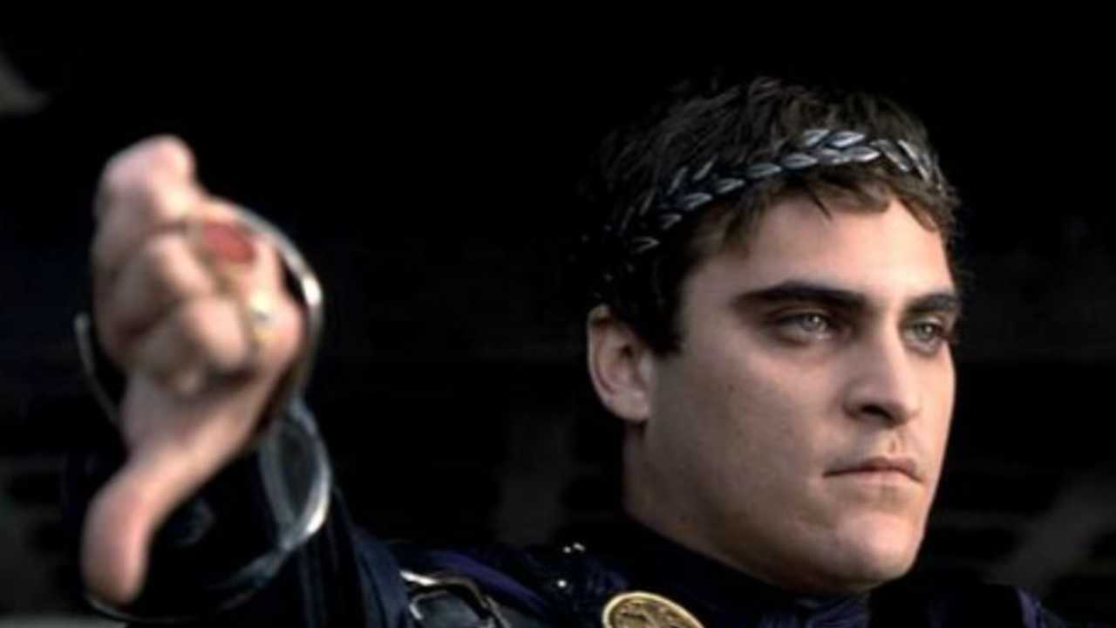
Describe, in detail, what kind of event you would organize. Where would it be, and what would be the form of entertainment? Why would Americans tune in and watch it?

