Monday Absolutism Journal
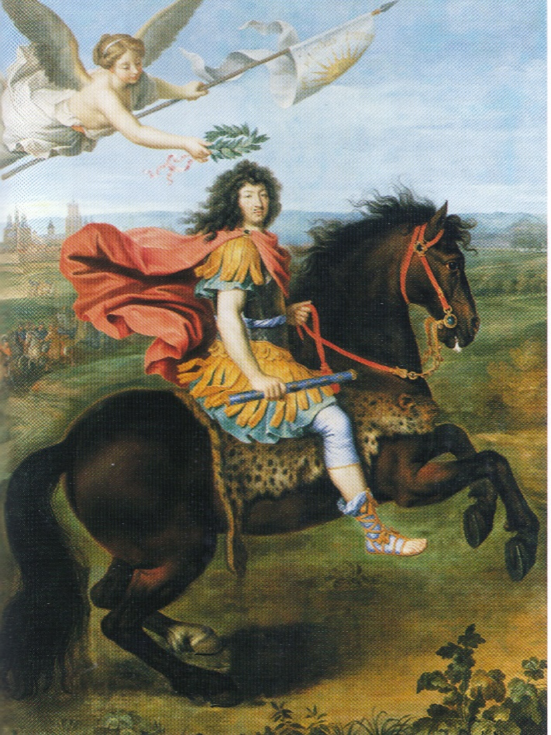
1. Who do you think is in the painting?
2. What is in the background?
3. What message does this portrait convey? What is the meaning?

Tuesday Journal

1. Describe 5 characteristics of a good leader?

2. What kind of things does a BAD leader do?

3. Who, in your class, would make a good leader and WHY?

Wednesday Journal

1. What invention has impacted the world the most and Why?

2. What is your favorite invention and Why?

3. Imagine a world without computers, phones, video games, the internet, and television. What would you do with your time instead?

Friday Journal Lecture Questions

1. Who’s ideas are right: Hobbes or Locke? Explain

2. Do you agree with Voltaire? Explain

3.Which form of gov’t is better:
Separation of powers or direct democracy?

4. Do you agree with Beccaria? Explain

