Middle Ages Map Skills
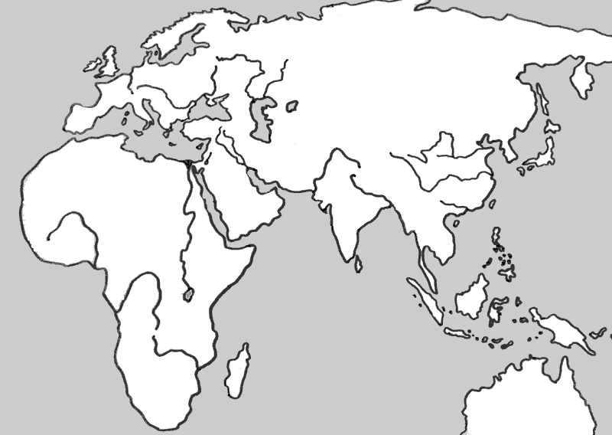

Label the continents of Europe, Asia, Australia, and Africa.
Label the Arabian Sea, Persian Gulf, Red Sea, Mediterranean Sea, Black Sea, and Caspian Sea.
Using a colored pencil, shade in the area held by these Empires: Mongol Empire, Holy Roman Empire, Islamic Empire, Mughal Empire
Mark with a dot and label these cities: Timbuktu, Jerusalem, Rome, Constantinople/Istanbul, Mecca, Tokyo, Medina and Baghdad

