Verus vs. Priscus

The Priscus and Verus' fight occurred on the first day of the games that celebrated the opening of the Coliseum. These games consisted mainly of gladiatorial fights, animal spectacles and staged sea battles. These games helped placate the Roman masses, and increased Titus' popularity to the end of his reign in 81 AD. Beginning during the time of Julius Caesar, coliseum entertainment tactically satisfied the Roman mobs' pent-up frustrations with their cheering on of the entertainments.

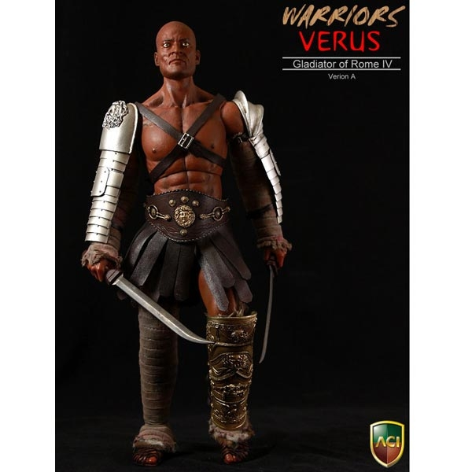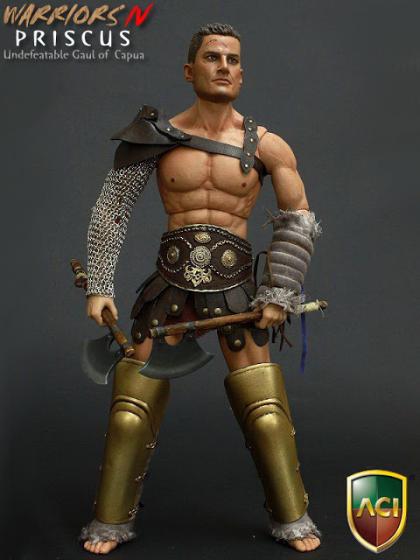
Their Oath:

In the sacramentum gladiatorium 'oath of the gladiator' the potential gladiator, slave or hitherto free man, said "I will endure to be burned, to be bound, to be beaten, and to be killed by the sword" uri, vinciri, verberari, ferroque necari. This oath bound him so that he was no longer truly free.

THOSE WHO ARE ABOUT TO DIE SALUTE YOU

