Friday Journal

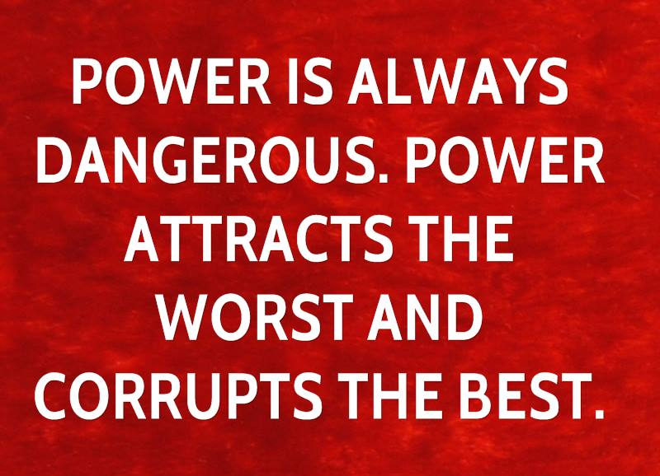
1. Explain what this quote means?

2. Do you agree with the point it’s trying to make?

3. Do you trust those in power in this country? Why or why not?

