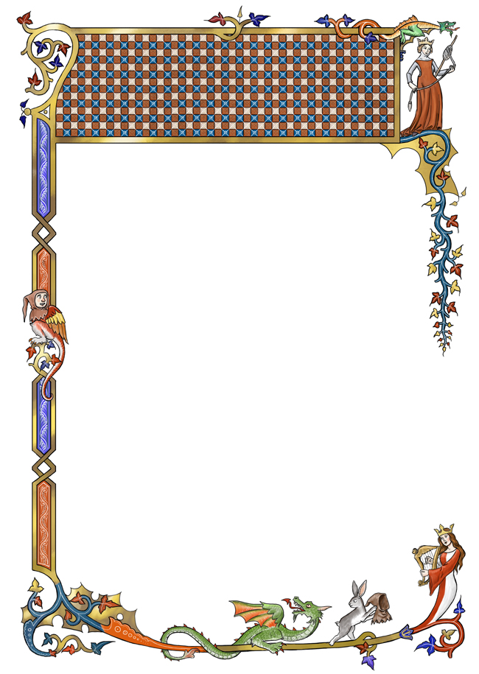
Feudal Manor Project

This project will assess your understanding of Feudalism.
Complete the following tasks for a test Grade.
1. Design your manor (50 points)
You will design your own Feudal manor. Your manor must be neat and use color. Be creative, but include all the elements!

    - Lord’s Castle
    - A Church
    - Serfs’ Cottages (at least 5)
    - A Barn
    - A mill
    - A Forest
    - A Pasture
    - Farmland
    - An Orchard
    - A Stream
    - A Pond
    - Two Roads connecting you to other manors nearby
2. Write A Letter (25 points)
You will write a letter to your best friend who lives at another manor. Write it in the first person and Include:

- What kind of work you do on a normal day
- What restrictions the lord places on you
- What you eat
- Where you live

3. Create a Coat of Arms (25 points)
The heralds need your coat of arms so they may introduce you at the next melee. Design one so your knights may be easily identified! Be sure it is neat, colorful and includes:

- The Coat of Arms is at least 8 x 10 in size
- It must have your Family Name and motto
- The Coat of Arms has a background or field color (minimum of two colors)
- The Coat of Arms has a charge (at least one animal)

