EasyBib Annotations

# How to Use EasyBib to create an annotated Bibliography

**Step 1**: Students will need to log in to EasyBib using their student email and password: bengals.

**Step 2**:

They should create a new project to save all their citations under.

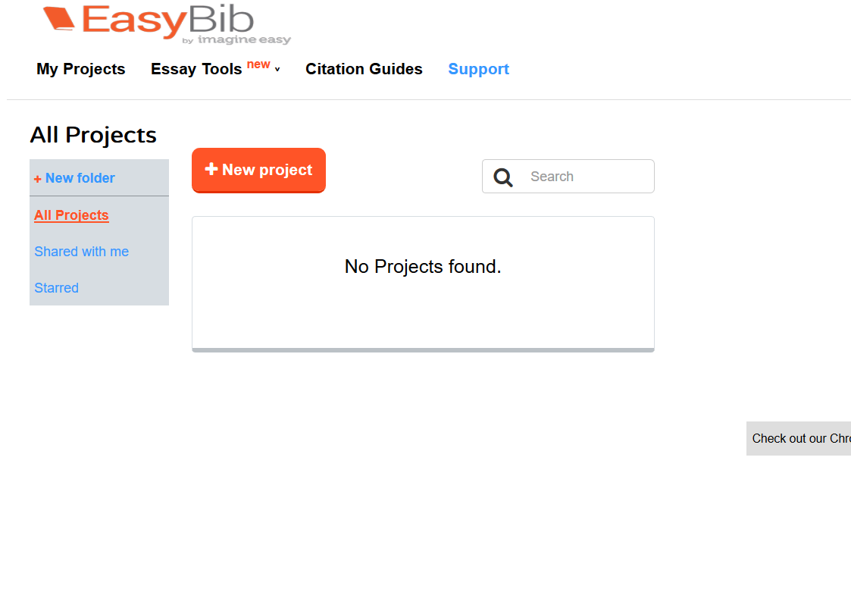

Name the project and include their issue question. Then Save

Step 3:

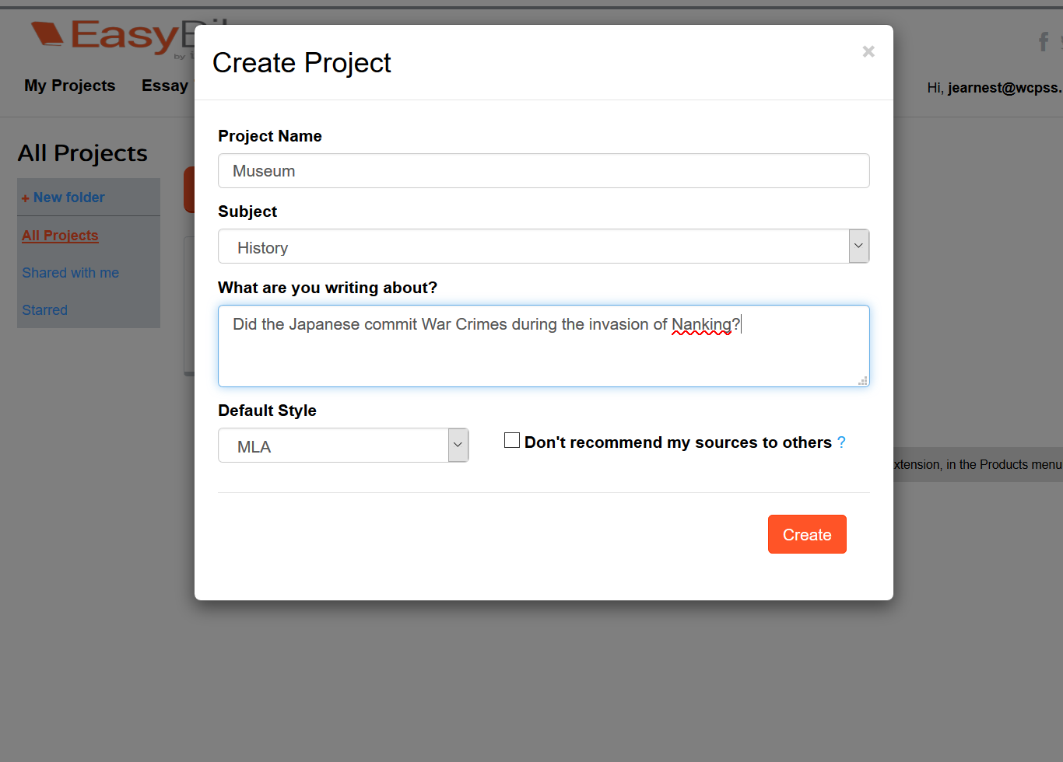

Step 4: 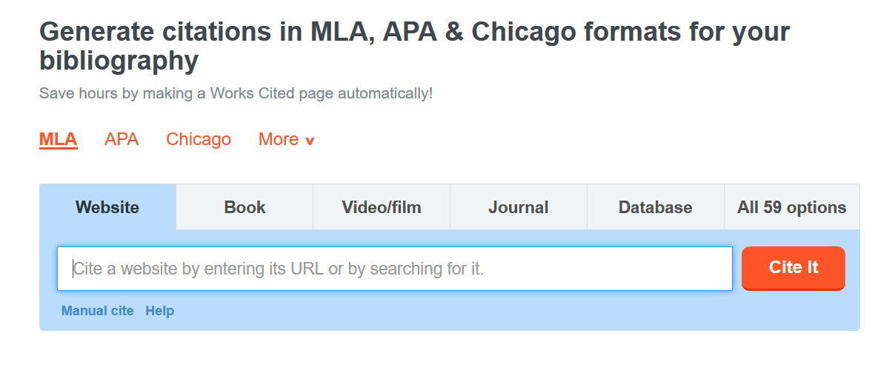

To add a citation, they can copy and paste the web address OR choose the correct option. In this case, I am citing a Newspaper article, so will select it.

**Step 5:**

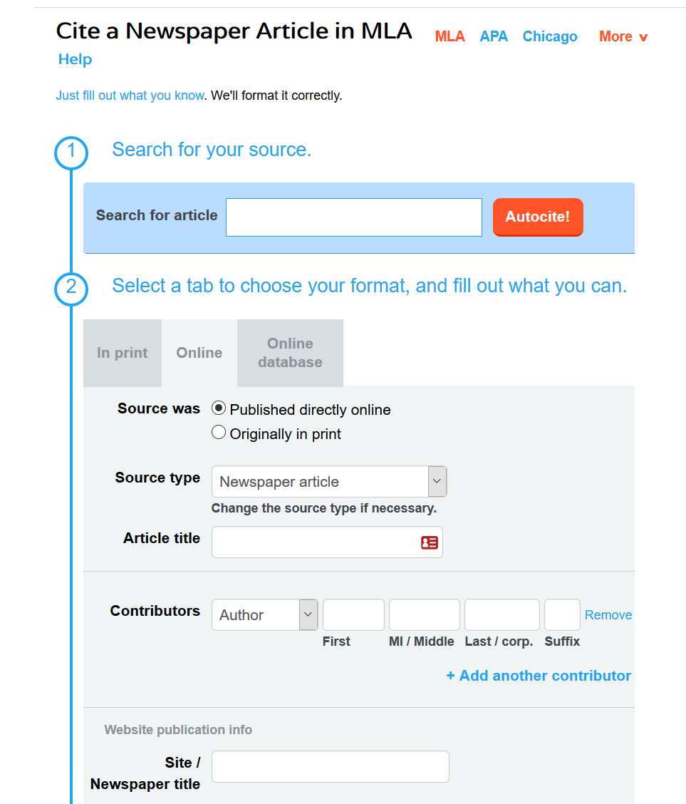

Now go through, make selections, and add information you know.

In this case, this was originally in print, so I will change this before adding information.

Step 6:

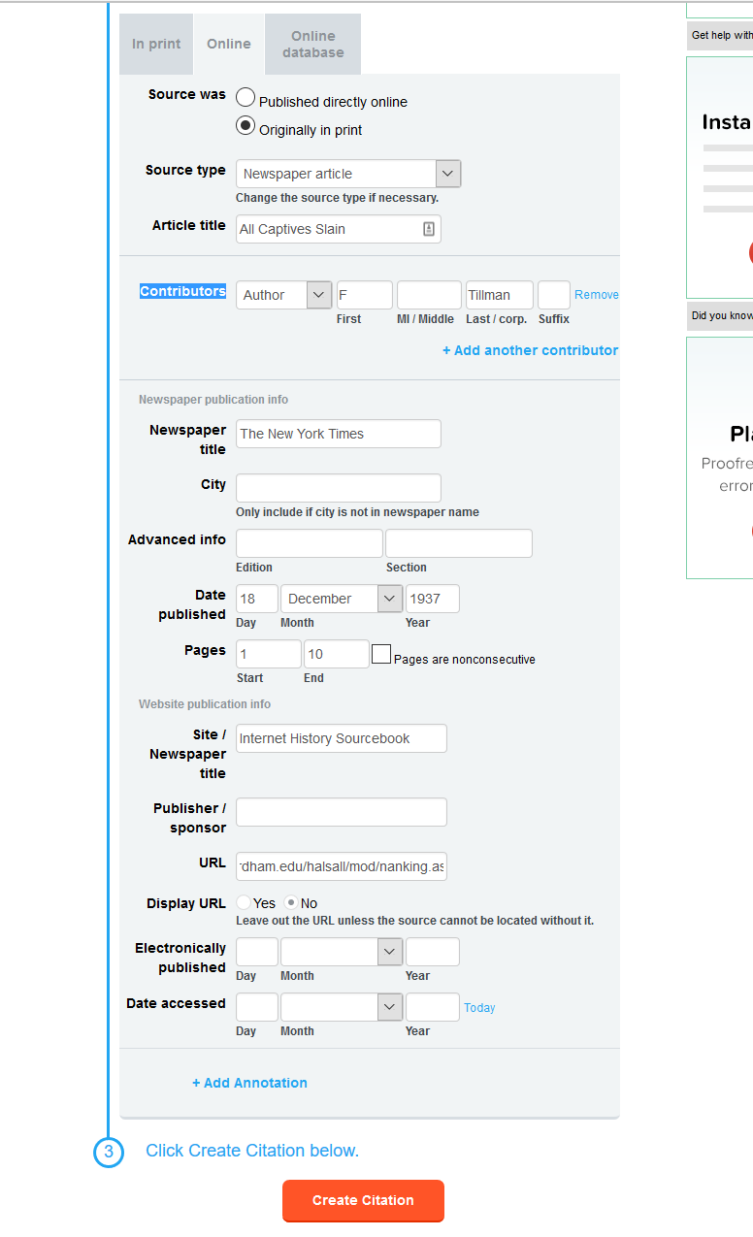

Add all the correct information and then choose “ADD ANNOTATION”

**Step 7:**

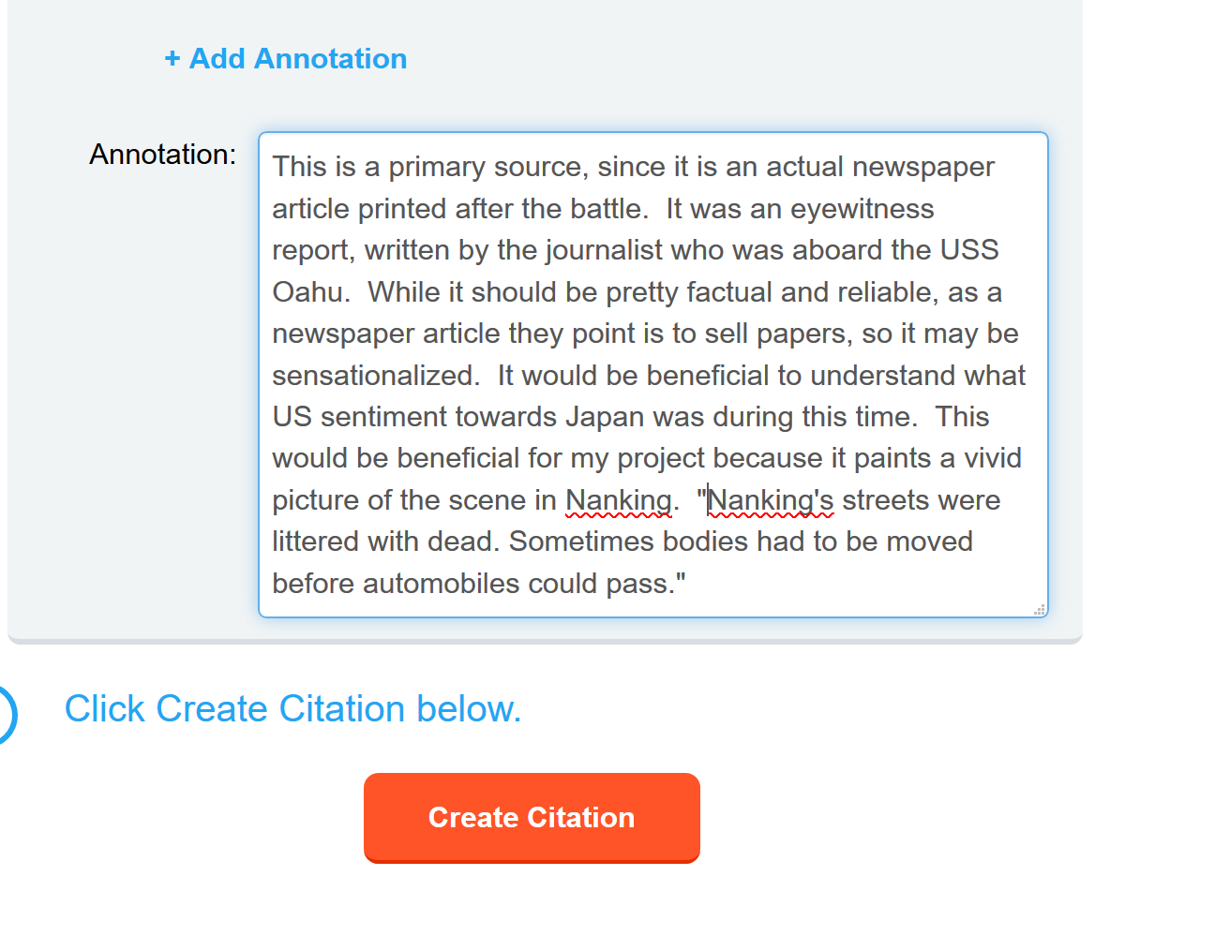

It takes them to a list of citations under the project. They can also get to this from the menu. When they are finished with ALL their citations, they can Share the Bibliography via email or Export it. Choose the format, and they can make changes before submitting it.

It will alphabetize them, but not separate into primary vs. secondary sources, so my students have been told to do those edits before submitting.

The annotation can be typed right into the box. After finished, click “Create Citation” It should save to the project they created earlier.

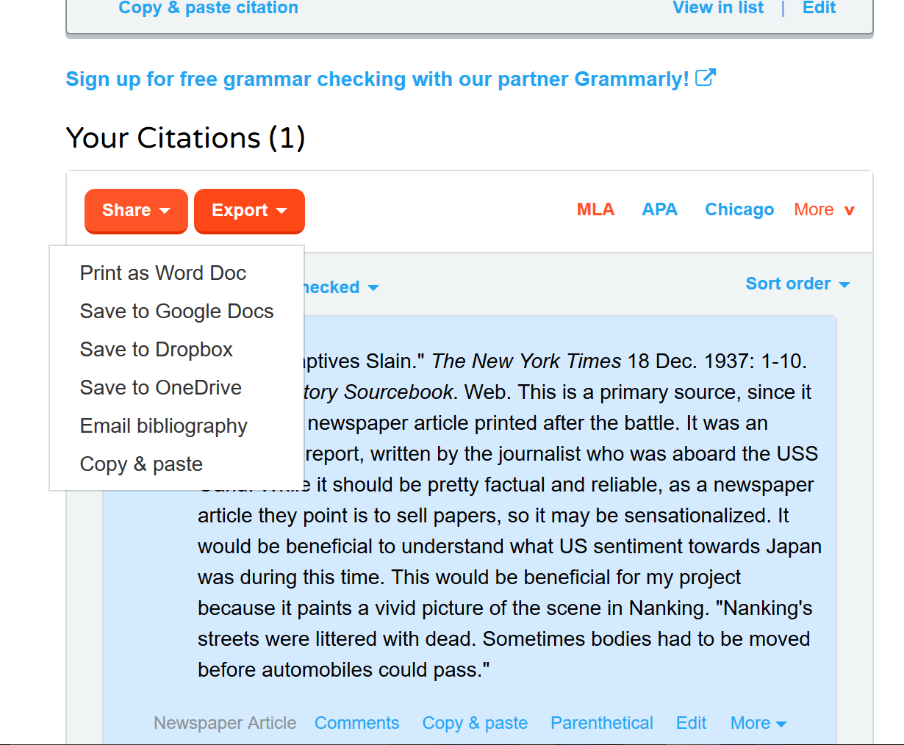**Step 8:**