Wednesday Journal

1. Do you feel that America is a fair place and that everyone, rich and poor, have the same opportunities? Explain.

2. Who are the most powerful people in America? What groups of people have the most influence?

3. What options do poor people have to make their lives better? What should they do if they do everything in their life right, but still don’t get the things they want?

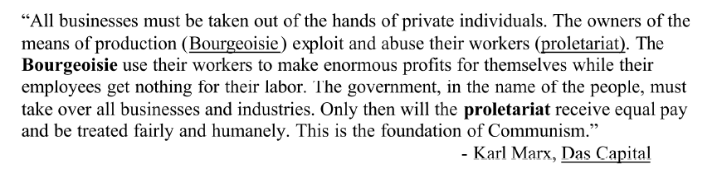
4. Do you agree or disagree with the quote above? Why or why not?

