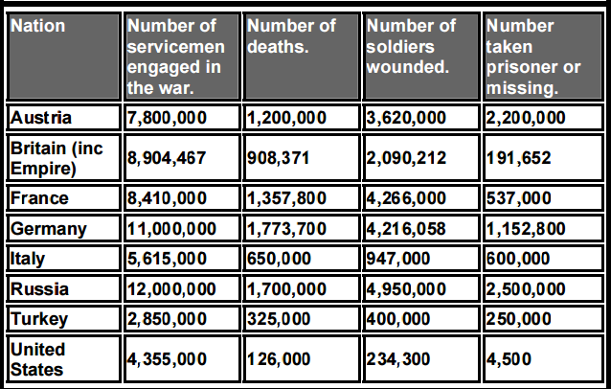

Answer the following questions:
1. Which country had the most soldiers in World War One?

2. Which country had the least soldiers in World War One?

3. Which country had the highest number of deaths?
4. Which country had the least number of deaths?

Causes of World War 1  M -  A -  I -  N - | 1. What agreement officially ended WW1?  2. What organization was formed, after WW1, to try and maintain world peace?

