Names of Group Members: Period:
RELIGION:

Where the Followers of the Religion Live

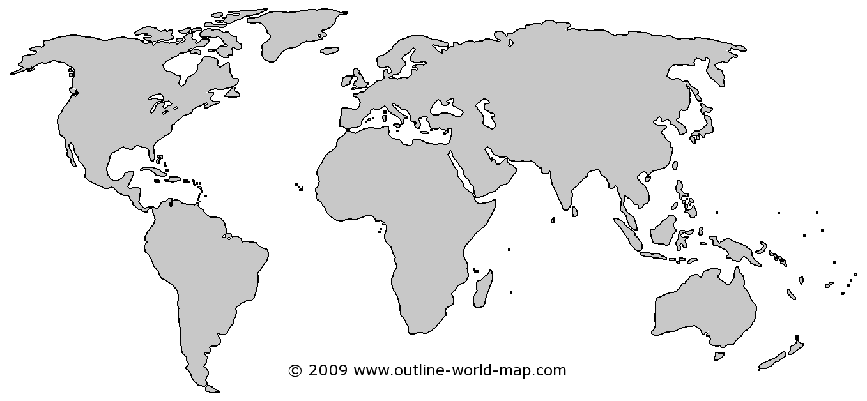

Timeline of Important Events in the religion

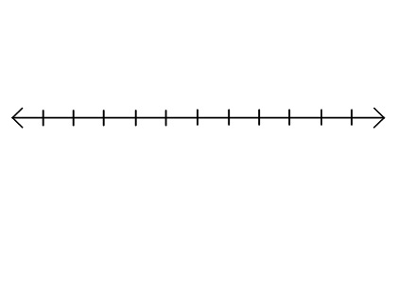

The number of people in the world that follow this religion is: ___________________

